HWS Art Competition - Terms and Conditions.

1. Adult entries are all anonymous and donated to the HWS for sale at £45. They must have no signatures or recognisable marks on the front. All entries are 8x8” in total (whether framed or unframed) and must have hanging fixtures on the back along with full contact details. They must not have been exhibited or published anywhere before. Any medium that can be hung is eligible.
2. Junior entries can be done in pencil, pen or paint on any paper with the design inside an 8” square on plain unruled white paper and contact details, school, etc, lightly written on the back so as to not to show through to the front. The child’s name can be shown underneath the design. These pictures will be judged for their suitability as a t-shirt or for use on other merchandise that may be printed for Hillswick Wildlife Sanctuary and any of their officers for fundraising purposes – by entering you are giving HWS your consent to do so. Junior entries will be pinned up unframed.
3. All adult entry forms must be sent to the address below by Friday 3rd April, with the artwork and fee being delivered to Room 12, Islesburgh on Friday 17th April 2020 between 1pm and 8pm. Postal entries with the fee to the address below by 3rd April 2020.
4. Junior competition entries to be handed with the £2 fee to teachers by Friday 3rd April, or individual entries (not via a school) to be posted by that date to the address below.
5. If you wish to have any unsold Adult artwork returned, you can collect it on Thursday 30th April between 2pm and 5pm or it can be returned by post at your cost.
6. The competition committee has the right to refuse any entry which it feels is unsuitable for display in a family environment, badly framed (clipframes are not accepted as they can fall apart) or potentially dangerous or fragile. If you are unsure, please send a photo before-hand to wildaboutart@yahoo.co.uk for a decision.
7. The committee takes no responsibility for damage to artwork while it is in storage or hung in the exhibition, although every care will be taken. Artists are at liberty to insure their own work if they wish. Prizes will be awarded by a panel of judges and their decision will be final.
8. The prize-giving for those who are able to attend will take place on Sunday 19th April at 2pm at Islesburgh, Room 12.
9. All cheques for entry fees should be made payable to Hillswick Wildlife Sanctuary, or cash or PayPal can be made to [wildaboutart@yahoo.co.uk](mailto:wildaboutart@yahoo.co.uk). Entries are one per person, £5 for adults, £2 for children.
10. The committee will hang or display all the entries if possible, but may have to choose a number of items to display if the number of entries becomes too big. The exhibition will be taken down on Thursday 30 April and all unsold Adult entries and kids’ entries can be collected on that afternoon between 2pm and 5pm, unless you have previously made arrangements with the committee. If there are any last minute problems in entering or collecting work, or general queries , ring

Anne Barron 07713 985081

email [wildaboutart@yahoo.co.uk](mailto:wildaboutart@yahoo.co.uk)

Address: (Bailey & Barron) Duncansclate, Bridge End,

Shetland ZE2 9UY

**Hillswick Wildlife Sanctuary**

**Art Competition & Exhibition, Islesburgh**

**17 – 30th April 2020. Junior Competition**

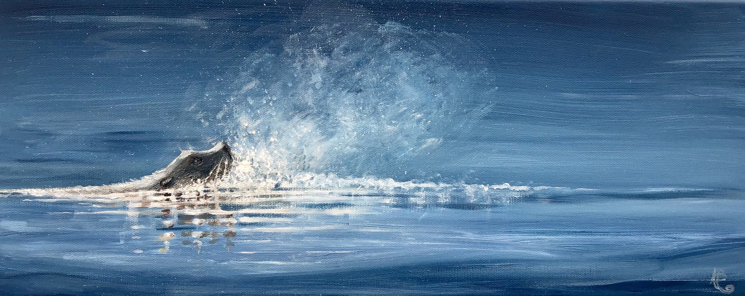

Please fill in the first part of this form when you hand your artwork in to your teacher by Friday 3rd April with your £2 entry fee (see terms and conditions). You should keep the terms and conditions for reference. If you are not entering via your school, please post your entry to the address at the bottom of the page to arrive by Friday 3rd April.

Name:

Address:

 School and class:

Telephone No: Email:

Please circle the age group you wish to enter:

13 - 16. 9 - 12. 5 - 8

Picture Title:

Your design must fit into a square 8” x 8” including any caption, words or letters. It can be in black and white or colour, using pencils, coloured pens or paint. The theme is “Our Precious World” and can be anything to do with wildlife, climate change, saving the planet, plastic pollution or conservation. It must be on unlined plain white paper and your name, school, age and home telephone number written in pencil lightly on the back.

All images will be displayed and there will be a winner and runner-up in each category with the prize-giving at Islesburgh, Room 12 from 2.00 pm on Sunday 19 April, all welcome. The images will be taken down on Thursday 30th April and can be collected between 2.00 and 5.00. If not collected, they may be destroyed. Please advise if you wish to collect after this date.

Mrs A Barron, (Bailey & Barron) Duncansclate, Bridge End, Shetland, ZE2 9UY. Tel 07713985081

I have read and I agree to the terms and conditions (attached)

$igned: